

Dear Members,

I hope that you have been enjoying 2nd half our summer athletics season at the Doncaster venue.

I would just like to remind you of the following schedule for the remainder of the summer season.

Please note that On-Track programs will continue as per the schedules tabled below.

**Saturday 10th February from 8.30am:**

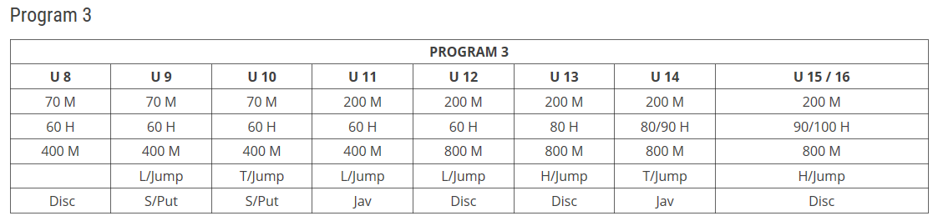

Note that CLAC will be providing a Pole Vault Clinic on Saturday to U14 and above athletes.

**Friday 16th February from 6.00pm:**

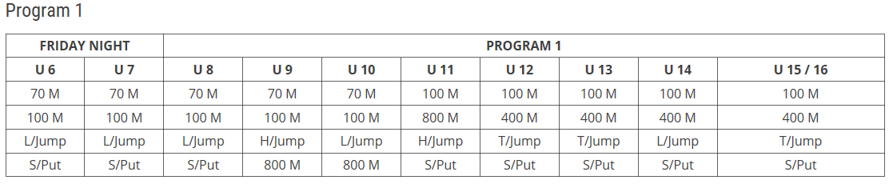

**Saturday 17th & Sunday 18th February (U9-U16 Only) – No On-Track Clinics**

EMR Track & Field Championships (Event Registered Athletes Only)

Note that all athletes attending this event must abide by LAVic Competition & Uniform Rules

(**No Jetstar Patches**).

Collingwood will have a venue tent available and parents must report into upon their arrival to the venue, as CLAC has been allocated duties which parents must assist with and the Team Manager can check athletes off also.

Failure by parents to perform duties will result in centre points being removed from athletes in question.

**Team Manager:** Eugene Nemesi (CLAC)

**Saturday 24th February from 8.30am: (The last official CLAC points event)**

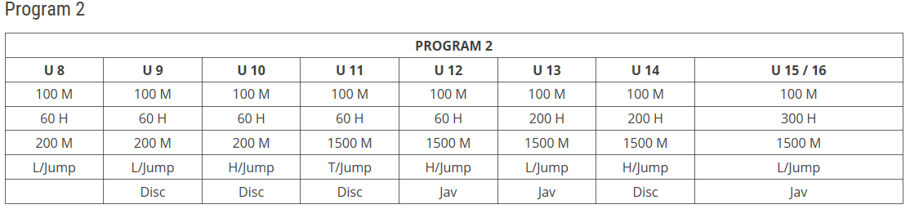

**Saturday 3rd March from 8.30am: (No CLAC points awarded)**

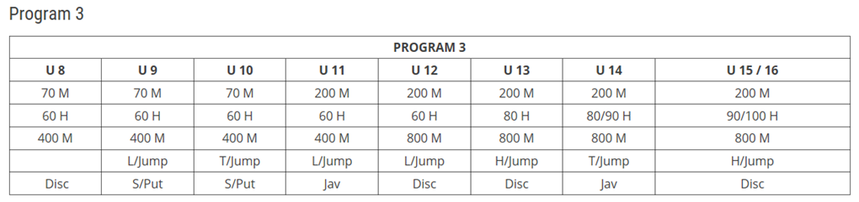

**Friday 9th March from 6.00pm: (No CLAC points awarded & No On-Track Program)**

|  |  |  |  |  |  |  |  |  |  |
| --- | --- | --- | --- | --- | --- | --- | --- | --- | --- |
| **Friday Night Handicap Event** | | | | | | | | | |
| **U 6** | **U 7** | **U 8** | **U 9** | **U 10** | **U 11** | **U 12** | **U 13** | **U 14** | **U 15 / 16** |
| 100 M | 100 M | 100 M | 100 M | 100 M | 100 M | 100 M | 100 M | 100 M | 100 M |
|  |  |  | 800 M | 800 M | 800 M | 800 M | 800 M | 800 M | 800 M |
| L/Jump | L/Jump | L/Jump | L/Jump | L/Jump | L/Jump | L/Jump | L/Jump | L/Jump | L/Jump |
| S/Put | S/Put | S/Put | S/Put | S/Put | S/Put | S/Put | S/Put | S/Put | S/Put |

**Saturday 10th & Sunday 11th March State Track & Field Championships**

Only applicable to athletes who qualified from Region Track & Field Championships.

**CLAC AGM & AWARDS Night:**

**6.00pm – 9.00pm on Friday 23rd March 2018 @ George Knott Reserve, Club Rooms Clifton Hill**

A light supper will be provided during the evening and more details will be provided as we get closure to the date. Eligibility to receive awards will be based upon the clubs’ criteria & points system as published on the CLAC website.

In order to assist the Committee to prepare for the event and minimise any waste of club funds, we will be sending out an RSVP invitation which will be posted on Team App & the CLAC Website. Note that **trophies/awards will only be ordered for those who submit this advice by no later than Sunday 4th March 2018**.

Forms can either be dropped off to a Committee member on Competition Days, posted to CLAC at PO Box 42, Clifton Hill 3068 or emailed to [collingwood@lavic.com.au](mailto:collingwood@lavic.com.au).

Note that CLAC Committee will be handing out CLAC Committee Nomination Forms in due course and they will also be made available via Team App and the Website. Please take the time to read the attached letter as it’s very important for the club to continue on in the future.

**CLAC Cross Country Season:**

Please don’t forget our cross country season starts in April 2018.



Note that the above schedule may be subject to change. The Club Cross Country Handbook will be made available shortly via Team App and CLAC’s website.